Populating Database

1. We get 100 cars’ data, including 50 items to be auctioned and 50 direct sale items to be sold from the Edmunds.com API.

We get data by calling, for example:

https://api.edmunds.com/api/vehicle/v2/makes?fmt=json&api_key={ cfj4zt9xwecz4wzhv3zr8yev }

The response of an example API call looks like:

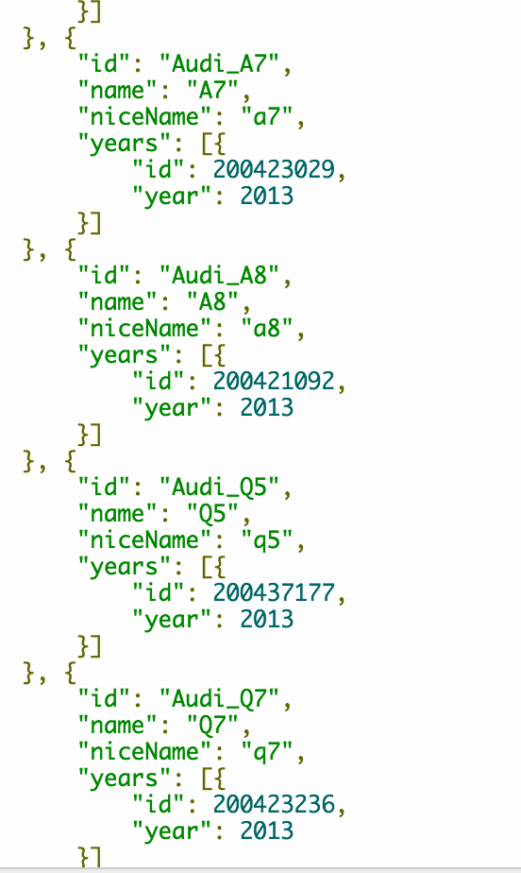

We get the user data from the Fake Name API by calling

https://v5.fakenameapi.com/generate

A sample response looks like:

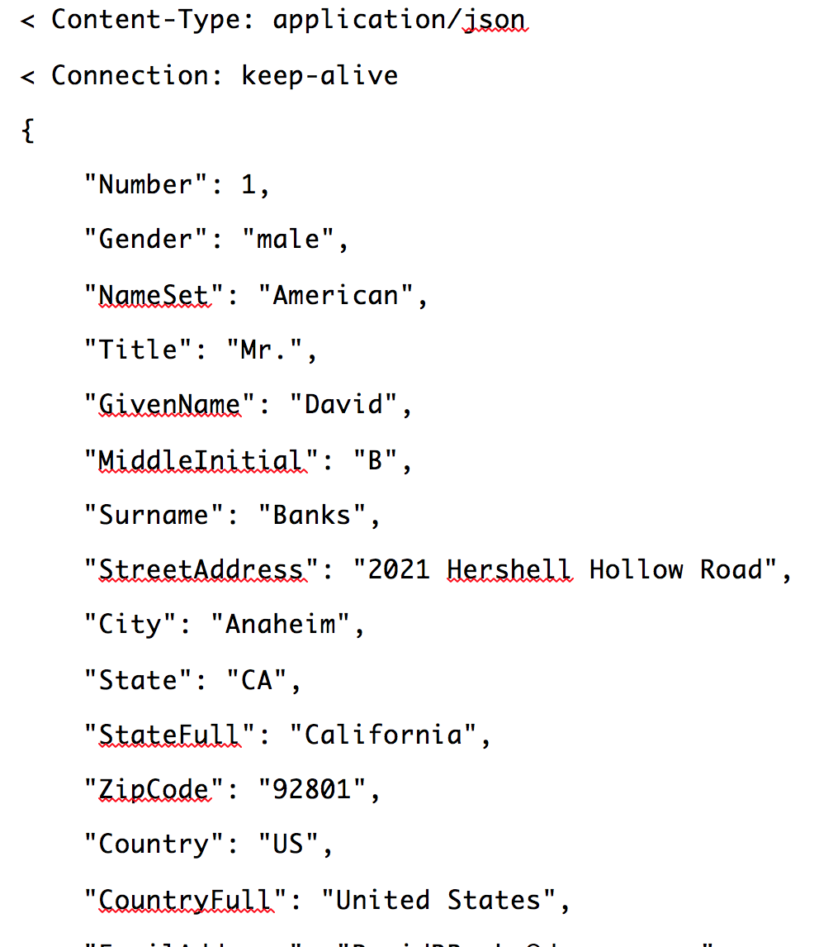

1. Then we further select the attributes that we need and store them in local files.

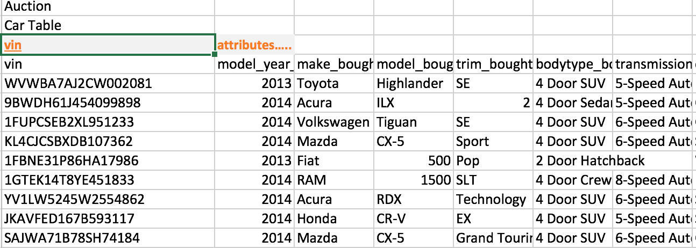

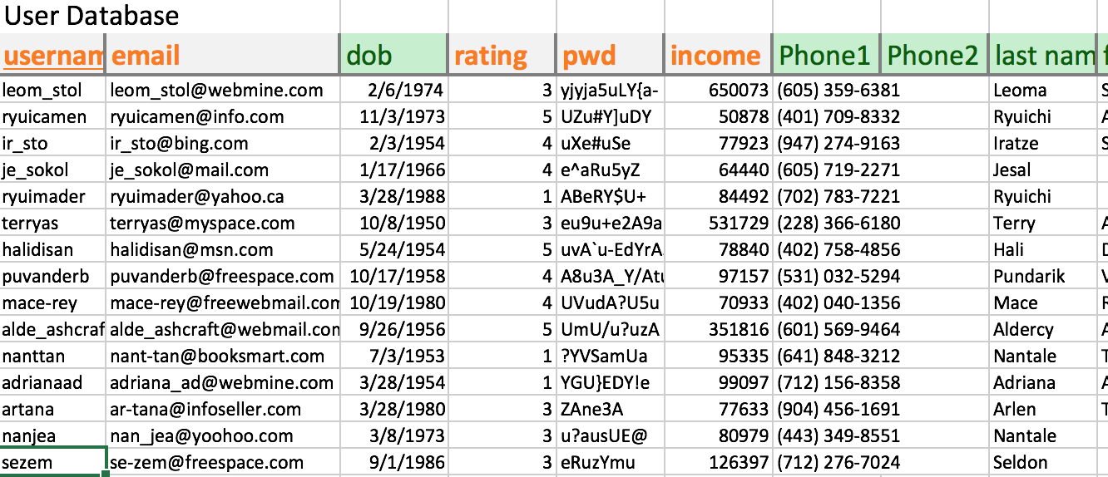

1. Our category tree starts with car as root. The root has three children: New, Used, Certified Pre-Owned. Then each child is divided by Make, like Mazda, Audi, etc.; and then further divided by Mode, like Mazda3, Mazda5, Mazda6, etc.

Our category tree looks like:

